E-Project Eproject Guide
Beauty Of Beaches

Group Members

- ZAIN UL HAQ
Student:1730727

- ZAYAN AHMED
Student:1730756

- RAHIM AHMED
Student:1730767

- STEPHNES BHATTI
Student:1733004

- MUHAMMAD MUSTAFA
Student:1730760

Faculty Members

Teacher: Miss Neha Shah
Coordinator: Miss Munazzah Khan

Table Of Content

- Introduction
- Objective of the Project
- Tools & Technologies Used
- System Requirements
- Key Modules & Features Description
- Project Code Snippets
- Website Screenshots
- Tak Sheet
- Conclusion

INTRODUCTION

BEAUTY OF BEACHES

The beauty of beaches has always attracted people with its natural charm, peaceful environment, and refreshing atmosphere. Beaches are a wonderful combination of golden sand, sparkling blue water, gentle waves, cool sea breeze, and beautiful sunsets. They provide a perfect place for relaxation, recreation, tourism, and spending quality time with family and friends. In today's digital world, technology provides an excellent way to explore and present the natural beauty of beaches. A well-designed web application can provide users with useful information about different beaches, their locations, attractions, activities, and natural surroundings in an interactive and attractive manner. Keeping the above concept in mind, this E-Project, “Beauty of Beaches”, is designed to provide an interactive platform where users can explore and learn about beautiful beaches. The project demonstrates how web technologies can be used to present information in an organized, user-friendly, and visually appealing way.

OBJECTIVE OF THE PROJECT
The main objective of the “Beauty of Beaches” project is to develop an attractive and informative web application that provides users with information about beaches and their natural beauty.
- Provide information about famous and beautiful beaches.
- Display attractive images and descriptions of beaches.
- Provide information about beach locations and attractions.
- Help users explore different beaches through an easy-to-use interface.
- Present information in an organized and visually appealing manner.
- Provide details about activities that can be enjoyed at beaches.
- Demonstrate the practical implementation of web development concepts.
- Develop a larger and more useful application by integrating different features.
- Improve technical skills through real-life project implementation.
- Create a user-friendly environment for exploring the beauty of beaches.
TOOLS & TECHNOLOGIES USED
HTML5: Semantic markup for structuring web pages, sections, and embedded media elements.
CSS3: Custom styling, layout management, animations, and responsive UI adjustments.
Bootstrap 5: Mobile-first responsive framework used for grid layouts, UI elements, navigation bars, and modals.
Bootstrap Icons: Scalable vector icons for interactive buttons, ratings, and navigation elements.
JavaScript (ES6): Client-side scripting for interactive features, slider logic, state management, and UI events.
jQuery & jsPDF: External libraries utilized for dynamic manipulation and exporting destination/wishlist details into downloadable PDF format.
Google Fonts: Typography enhancement ('Inter' and decorative sans-serif fonts) for improved readability.

SYSTEM REQUIREMENTS
Hardware Requirements
- Processor: Intel Core i3 (2.0 GHz or higher) / AMD equivalent
- RAM: Minimum 2 GB (4 GB recommended)
- Storage: 100 MB available disk space for web application files
Software Requirements
- Operating System: Windows 10/11, macOS, Linux, or modern mobile operating systems (Android/iOS)
- Web Browser: Google Chrome, Mozilla Firefox, Microsoft Edge, or Safari (Modern browser with JavaScript enabled)
KEY MODULES & FEATURES DESCRIPTION
- Code Editor: Visual Studio Code / Sublime Text (For development)
  - Home Page & Hero Banner: Features an interactive image slider showcase with dynamic text overlays, rating badges, and call-to-action buttons for trip planning.

  - Beach Gallery: A responsive image gallery displaying top international beaches with hover zoom effects and high-resolution visuals.

  - Zones (Tabbed Section): Categorizes beaches into geographical or activity-based zones with dynamic tab switching, heart-icon wishlist functionality, and PDF download triggers.

  - Travel Table & Route Finder: An organized tabular view detailing beach locations, ideal travel times, and distance/route guides for travelers.

  - Traveler Reviews & Star Ratings: An interactive review module featuring user feedback, filterable star ratings (5-star, 4-star, etc.), and real-time interactive star selectors.

  - Contact & Inquiry Form: A structured form for visitors to submit inquiries, feedback, or booking consultations.

  - Wishlist & PDF Download Feature: Allows users to save their favorite beaches using interactive heart icons and generate/download customized travel summaries in PDF format via jsPDF.

Screenshots

HOME PAGE :
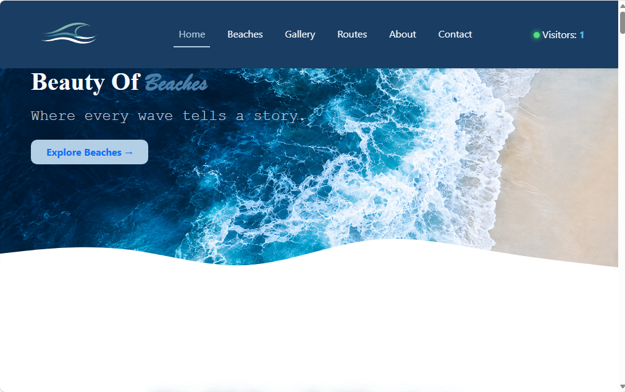
Navbar:


Hero Section: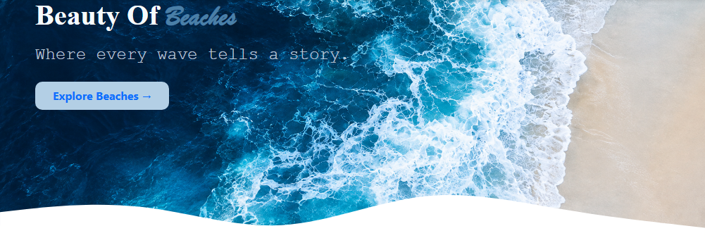

Popular Beaches: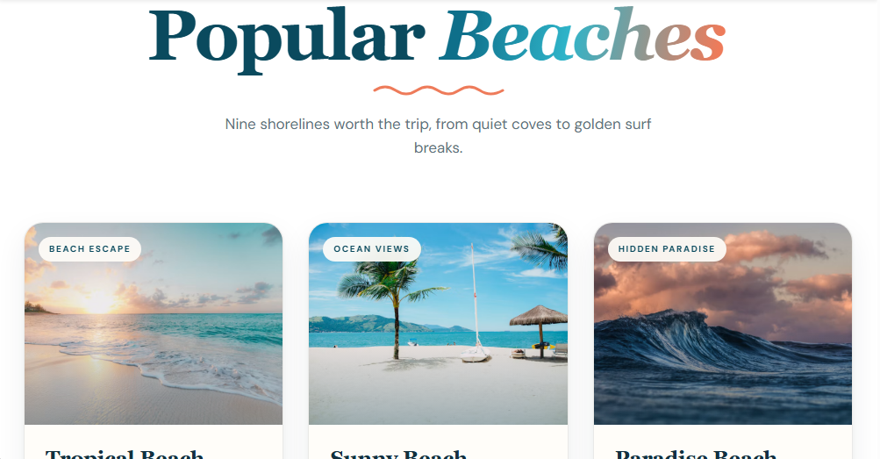

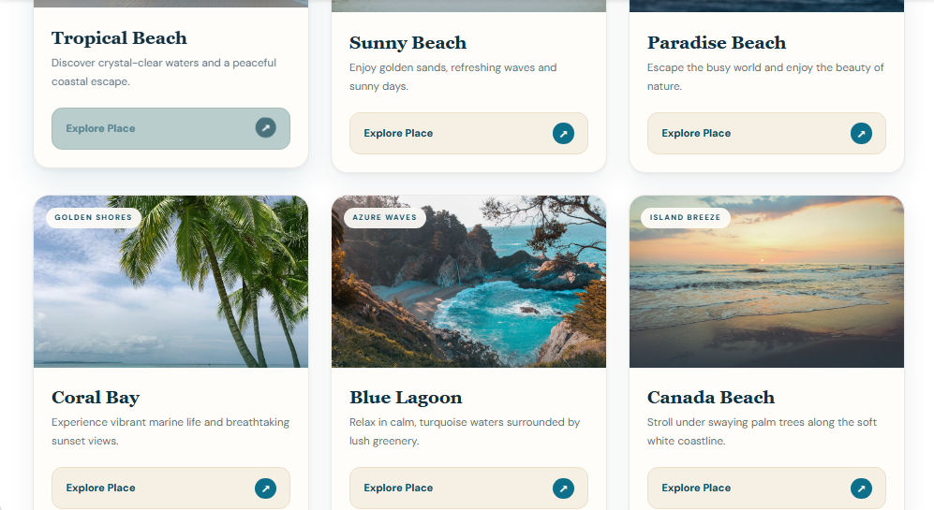

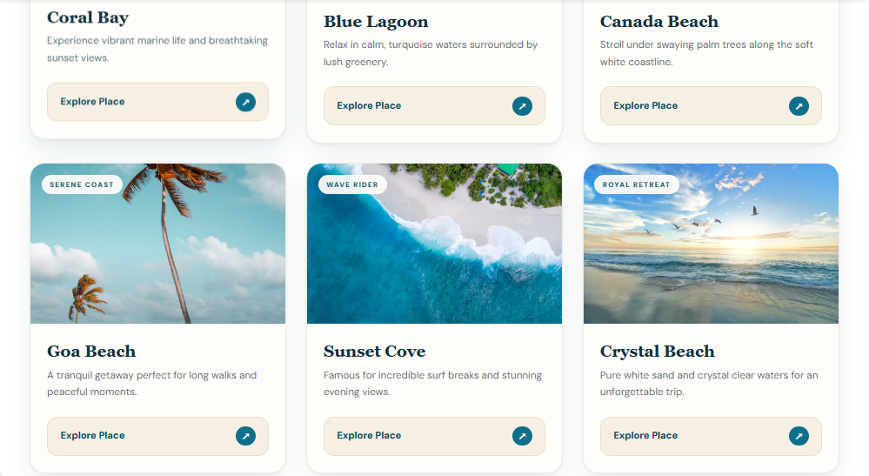

Beaches Zone Wise:
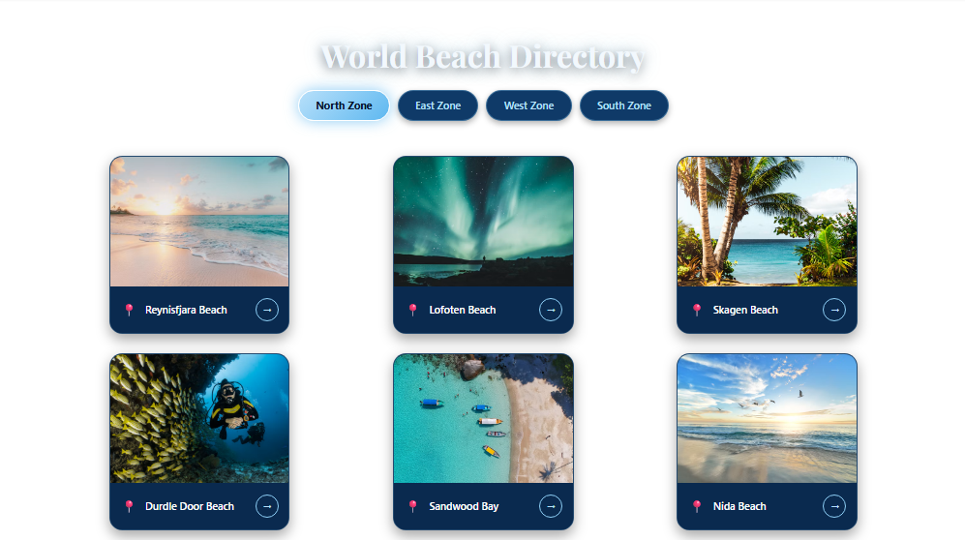

Gallery Section: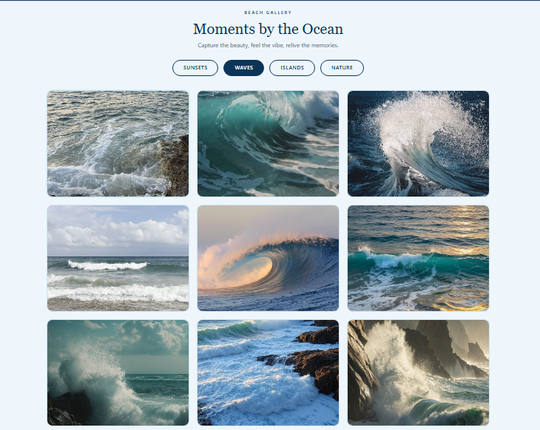
Routes Section: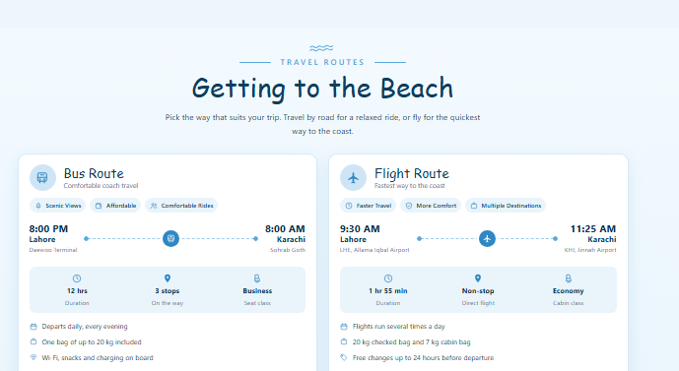

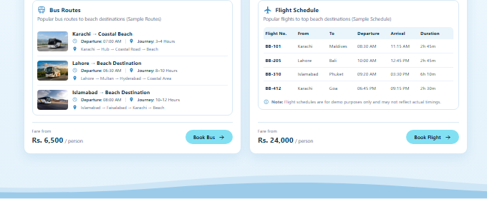

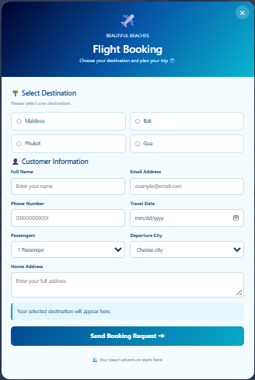
Routes Section Booking Modal:
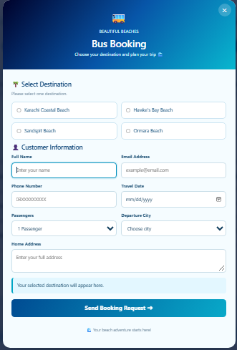

Review Section:
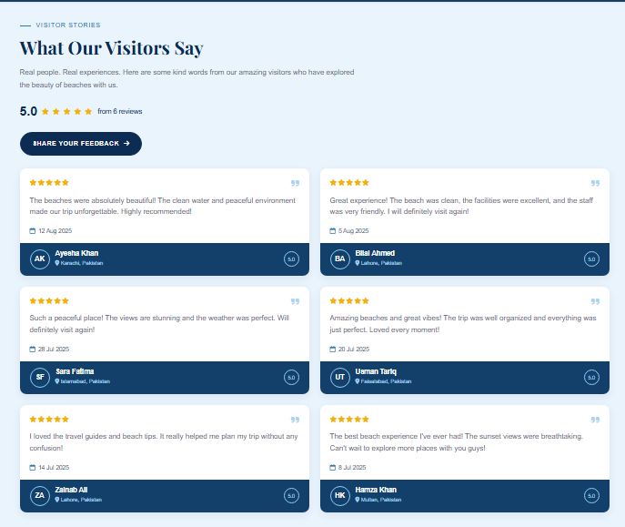

Review Submission Form:
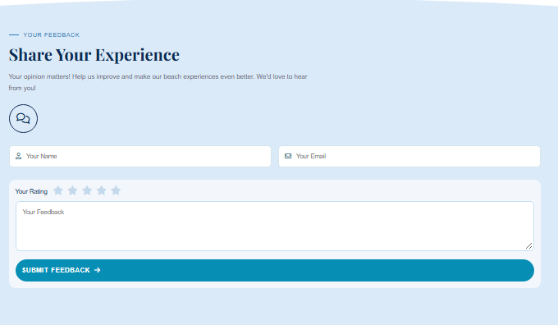

About Us: 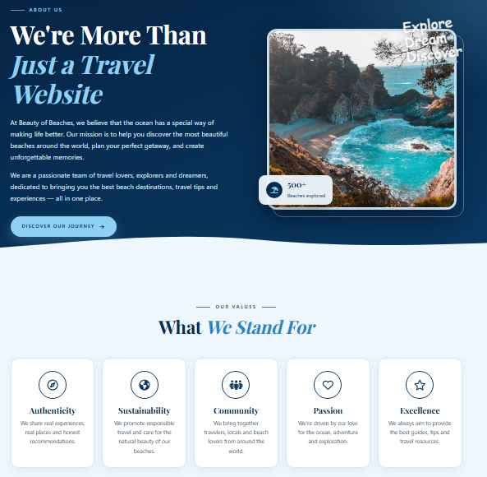
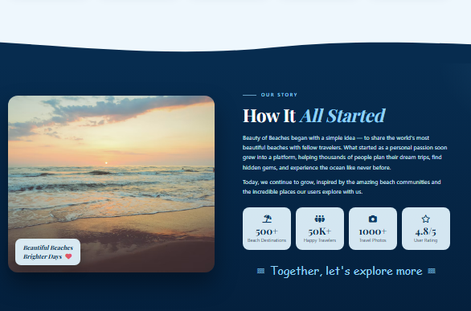

Contact Us: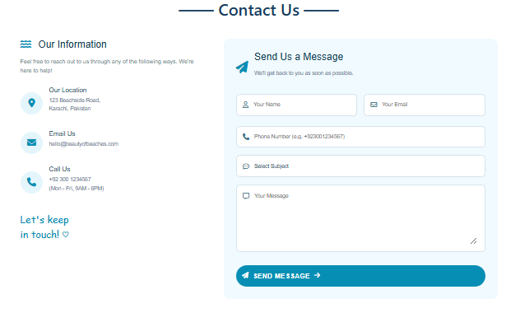
Footer:
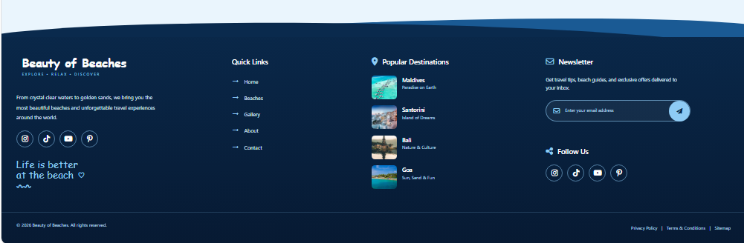

CONCLUSION
The "Beauty of Beaches" e-project successfully demonstrates the practical implementation of modern front-end web development tools. By integrating HTML5, CSS3, Bootstrap 5, JavaScript, and external dynamic libraries like jsPDF, the team created a responsive, interactive, and visually engaging web application. The project enhanced our technical problem-solving capabilities, UI/UX design standards, and collaborative development skill
THANK YOU

